Weight Gain

Weight gain is an increase in body weight. This can involve an increase in muscle mass, fat deposits, excess fluids such as water or other factors. Weight gain can be a symptom of a serious medical condition.
Weight gain occurs when more energy (as calories from food and beverage consumption) is gained than the energy expended by life activities, including normal physiological processes and physical exercise.

If enough weight is gained due to increased body fat deposits, one may become overweight or obese, generally defined as having more body fat (adipose tissue) than is considered good for health. The Body Mass Index (BMI) measures body weight in proportion to height, and defines optimal, insufficient, and excessive weight based on the ratio.

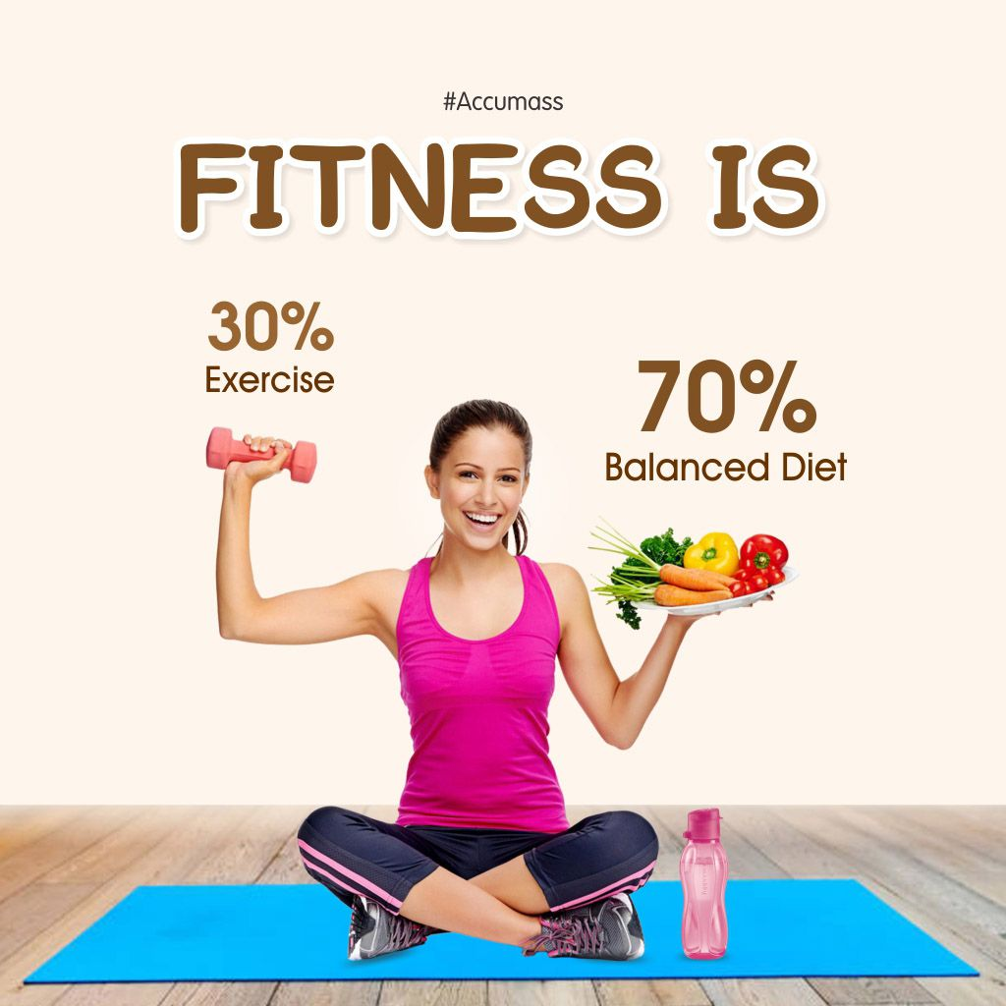

Advantage:
1. When you don't get all the calories you need, your body conserves energy to maintain the operation of essential functions -- such as the action of your internal organs and blood flow.
2. Gaining weight doesn't just help you gain more physical energy, but mental energy too.
3. Being too thin means you don't have the muscle mass or energy to do your best in sports.
4. Mass Gainers contain fibre. This keeps you away from being bloated and improves digestion. It is a great way to achieve overall health and fitness.
5 Mass Gainers keep you healthy and fit. They are a good mix of different minerals and vitamins that are an important nourishment source for your body to stay healthy and fit.

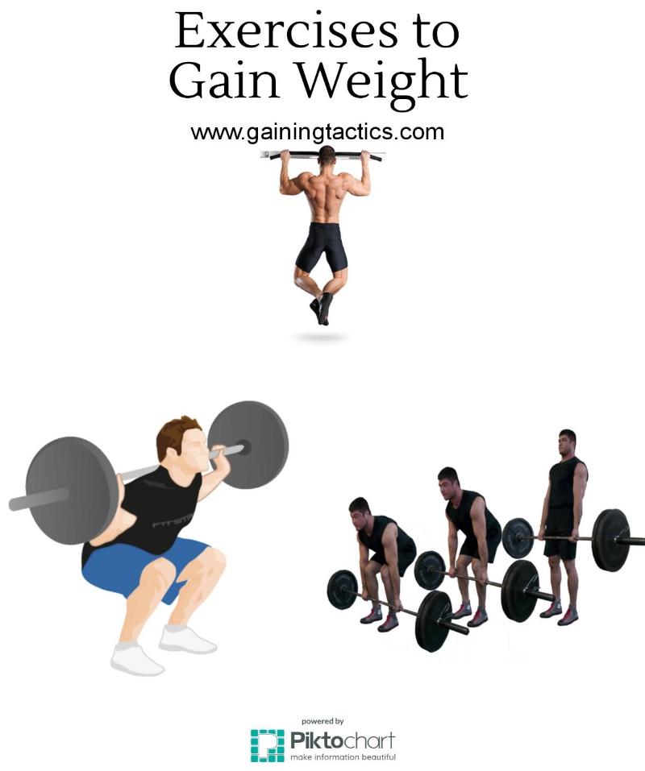

Different Exercise mostly Prefer

1.Push-ups
1.Lie face down on the ground.
2.Put your hands on the ground, palms flat, with your arms out at your sides and your hands shoulder-width apart.
3.Slowly push your body up until your arms are fully extended. Keep your back and legs straight so that your body makes a straight line.
4.Slowly lower yourself back down until your nose nearly touches the floor.
5.Repeat as many times as you feel comfortable.
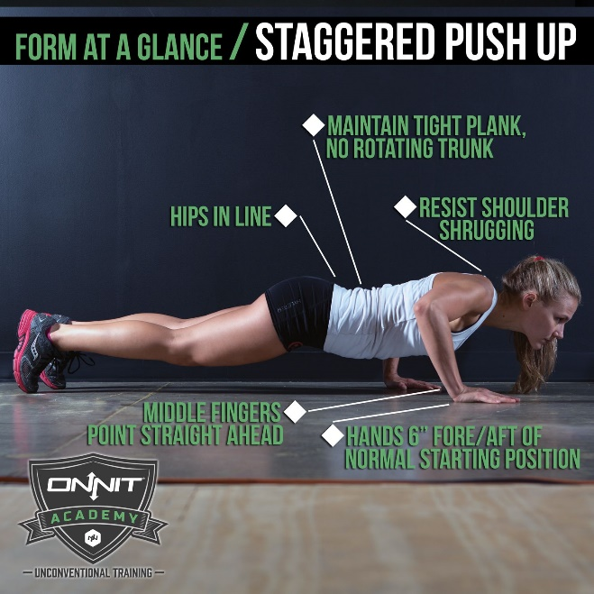
2. Pull-ups 3.Squats 
Mass Gainers contain a rich amount of carbohydrates. These carbohydrates supply you with the required energy that is very helpful for an intense workout.
Mass Gainers contain high quality of Whey Protein, which is an amazing supplement for bodybuilding. Some Mass Gainers also come with dietary fat. This dietary fat can help you achieve a lean physique.
Mass Gainers keep you healthy and fit. They are a good mix of different minerals and vitamins that are an important nourishment source for your body to stay healthy and fit.

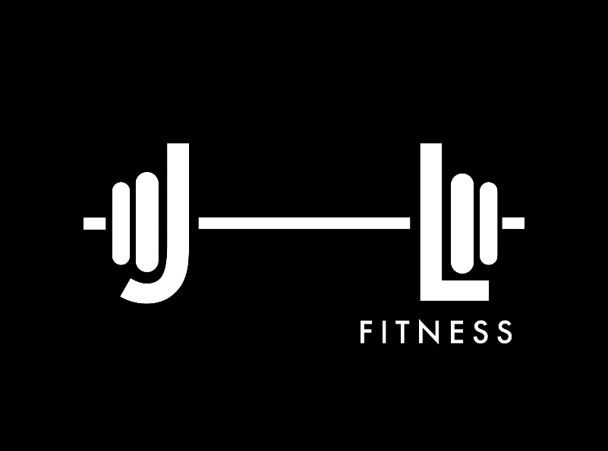

Thank You

